AKYODE
people name Akyode (sing Okyode-nyen, Okyodebi,or Okyode-kyii), Achode, Atwode, Adjuati, Adwati
to others ?
language Gikyode
home area Akyode-gɛsinkpan (Akyo-ide means “we detest this”, ie shedding human blood) area about 190 sq km
other local peoples Challa, Kotokoli, Adele
main village Shiare, on the hill-top (both the chief of Akyode and the priest of Brukuu (Brukun?) have their official seats in Shiare, but in 2011 they both resided in Nkwanta)
chief (name?) (Awuku Abbey ???)
name of God Wurubuaare
principal local god Brukun, Brukuu? shrine and priest are in Shiare on hill-top
main occupation farming

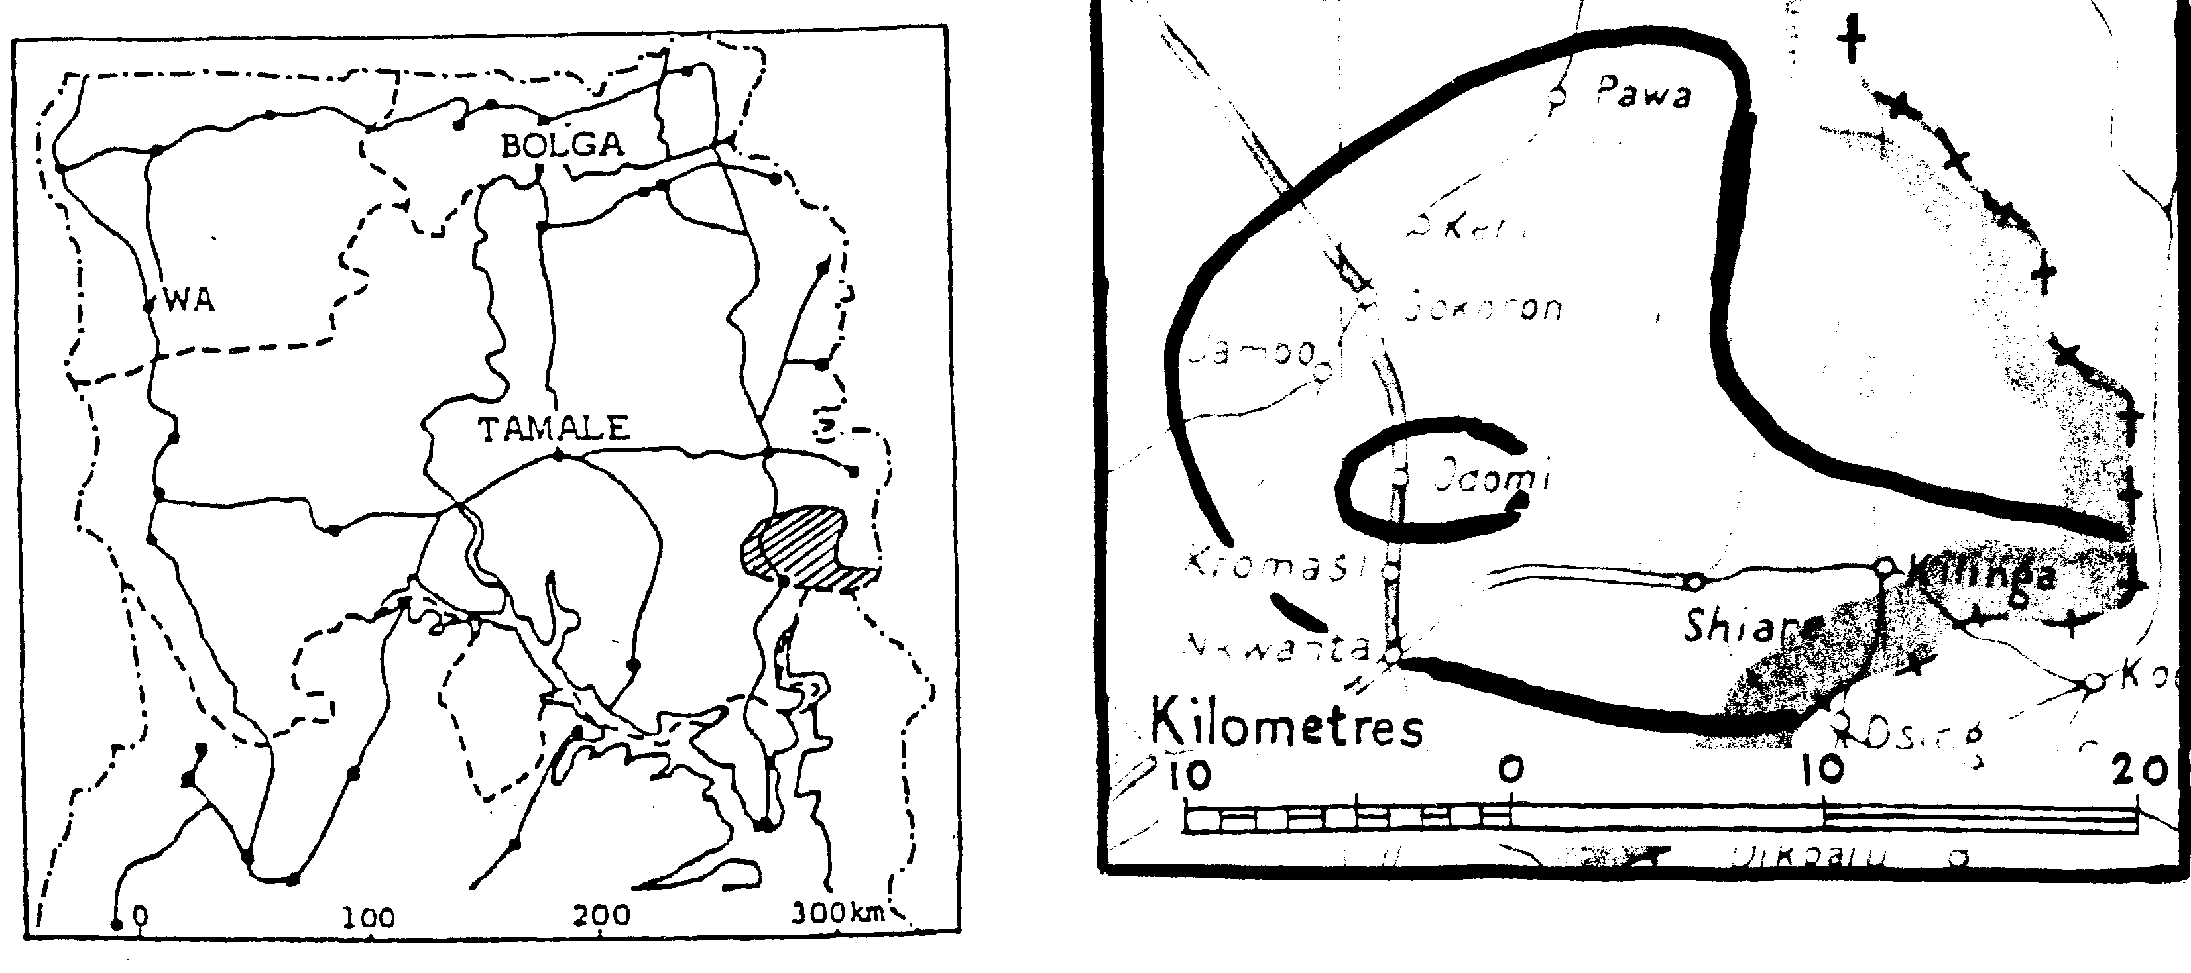

location a crescent-shaped string of villages reaching to the Togo border, in Volta Region, Nkwanta District, and immediately NW of Nkwanta
AKYODE – A PERSONAL VIEW
(I need someone to write a few hundred words about Akyode, on a general, non-technical theme, just to bring the situation to life before dealing with the routine, factual sections of the chapter. This feature should give readers a feel for the Akyode identity and what makes people proud to be an Okyedebi. Krachi’s “personal view” describes how it was isolated by the Lake – the Bissa one reflects the reputation of “Busanga” soldiers. What theme is appropriate for Akyode?)
POPULATION
Table 1 COMPARED BY YEAR
 | 1960 Census | 1984 estimate | 2000 Census | Joshua Project 2005 estimate | 2010 indep’dt estimate
Volta Region | 3,130 | 4,883 |  | 13,280 | 13,000
Other 7 Regions | 40 | 72 |  |  | 2,000
GHANA Total | 3,170 | 4,955 | not listed separately* | 13,280 | 15,000
TOGO estimate
*See table “Combined population of Akyode, Krachi, and Nawuri (2010 estimate)” in Krachi chapter, page XX
LANGUAGE AND DIALECTS
Gikyode is a Kwa language of the Guang (north) sub-group, most closely related to Chumburung and Krachi.
The Genyanga dialect is spoken across the border in Togo, and is mutually intelligible with the Gikyode spoken on the Ghana side.
Language use Until the 1990s Twi was the trade language and the language taught in schools and used in most churches. The Gikyode NT has been used in churches since 2001.
LITERACY/BIBLE TRANSLATION

by GILLBT | NT started | NT printed | Literacy students enrolled | OT | other
1979 | 1983 | 2001 | 1980s: 370  [2010: ?] | started 2007, 43% (17 bks) drafted in 2009); what %age by 2011? | 3,000-word dictionary
ORIGINS AND HISTORY
Akyode traditions trace their origins back to the defeat of the Guang king Ataara Finam VIII by a combined force of Akyem, Denkyira, and Akwamu in the Afram Plains in 1693-1700. The Akyode led by Nana Sei Mireku headed for the Togo mountains and settled at Gɛlun, NE of present-day Shiare. Nana Mireku’s brother Akora Kora Bediako led another section to Djarekpanga in present-day Togo, then to present-day Abrewankor, constituting the present Nifa Division. Another clan led by Kyagbale founded a settlement at Kyiliŋɛ, and formed the Adonten Division. Nana Sei Mireku moved on to Sei-ade or Siade meaning Sei’s people, which became Shiare. (EA)
In 1964 an eastern trunk road was built from Ahamansu to Nakpayilik and Bimbilla, as an alternative to routes to the north through Bole, Buipe, and Yeji. This road opened up access to fertile land in Nkwanta District, and large new Akyode settlements started at Bonakye, Kpassa, Sibi, Damanko.
AUTHORITY
Each town or village has heads of clans and royal families, who select candidates for the stool according to traditional standards, and in rotation of eligible families. The chief of each town has a title and a role, as follows:

Gikyode name | Twi name* | location
Osulewura | Ɔmanhene | Shiare
Ansidorwura | Adontenhene | Kyilinga
Gyisewura | Nifahene | Abrewanicor
Benewura | Benkumhene | Nyambong
Atowura | Gyaasehene | Kromase
Gamarawura | Kyidomhene | Keeri
Adeebowura | Ankɔbeahene | Odome
Gesennewura | Twafohene | Gɛkoron
Okpawura | Ahɔhohene | Bonakye
Gekpalanwura | Bedwamhene | Kue
(*for chieftaincy titles, see Introductory Notes)
Tribute is paid to local chiefs who pay to divisional chiefs, who pass it on to the paramount chief. Odome (Challa) does not pay tribute to Akyode .
The chief of Kue is acknowledged as paramount chief of all Kotokoli in Ghana, and a majority of the Kue population are Kotokoli. However Kue pays tribute to Akyode.
Odome is nominal seat of the Challa chief, though he resides in Nkwanta.
Kue and Odome used to pay tribute to Akyode, but no longer do so. [when did they stop?]
INHERITANCE
The one chosen to conduct the funeral inherits from the dead person, including the right to marry a widow.
COMPOUND (does this section need updating?)
A man occupies a compound together with his wives and children, unmarried sisters, and other relatives if necessary. Female children live with their mothers, and male children over a certain age live in a separate building with the father.
Some 30 people may live in one compound, which formerly consisted of several separate buildings with rectangular or square rooms and a central courtyard. The wives cooked in their bedrooms, and sometimes several wives' bedrooms/kitchens were built together in a row. [Are there still as many as 30 people in a compound?] Compounds are built close together. In 2009 most houses are built with cement blocks or bricks and iron roofing sheets.
FARMING, TRADE, AND DAILY LIFE
Farms may be 5 km from the village; crops grown include yams, corn, cassava, plantain, maize, groundnuts, tomatoes, pepper, okra, etc. Antelopes were formerly hunted but are getting rarer.
Mango trees are planted in town except for Shiare which does not have enough land for building.
Crafts include making baskets and mats, and pottery. Carving spoons and stools has died out.
Markets In the 1980s Nkwanta was the only market in the area. Since 2000 there have been markets in:
towns | days
Keri | Sunday
Nkwanta | Monday
Pang | Thursday
Nyambong | Thursday
Bonakye, Kpassa, Kabiti, Kue | Saturday
Traders bring imported goods and fish, soap, salt, cloth, kerosine, etc to these markets, and buy local products such as honey and gari.
Water Formerly water was collected from the nearest river. Boreholes began to be introduced in the 1990s.
Food The staple foods are fufu, kokonte, and TZ. Banku and rice have been introduced.
Transport The road from Nkwanta to Shiare was completed in the 1950s by local initiative and communal labour. No lorry reaches all the way to Shiare, but cars and buses run daily to Hohoe, Dambai, Damanko, Dadiase, Kabiti, and Kue.
RELIGION
estimated %age | Traditional | Muslim | Christian | No religion
1986 | 95 | 1 | under 1 | ?
2006 | 5+ | under 1 | 55 | 15
Traditional religion
God is known as Wurubuaare, which means “almighty” or “possessor of all things”. Though frequently mentioned, and seen as a defender, protector, and provider, he is felt to be remote.
The god Brukun has his shrine at Shiare, and it used to be visited by some 3,000 pilgrims every year, including people of many other tribes. In past centuries it is said that Gonja, Ashanti, and Dagomba chiefs used to consult Brukuu before going to war. In the latter 20th century it is said that Kwame Nkrumah and Col Acheampong visited the shrine and asked for help.
In 1995 Brant said that Brukun
draws considerable wealth to the village of Shiare. Visitors must be housed and fed. Somebody has to eat the sacrificed rams and sheep. Many of the priests have large houses in which rooms are rented and meals are prepared . . . It becomes clear that any religion which will interfere with a fetish poses a threat to the whole economic system of Shiare.
Pollock reported that the god itself is an "hour-glass-shaped stool about two feet high with two metal staffs three feet high with a pear-shaped object at the top".
Membership in the cult is restricted to Akyode males of agnatic descent. They must be illiterate and can be neither Christian nor Muslim. Initiations are held only two or three times per century. The last one occurred in 1962. At present there are 162 cultic priests.
Other gods include Gɛgon (god of war, who has shrines at Nyambong, Kyiliŋe, Kromase, Keeri, and Gɛkoron) and Gɛgyooga (god of peace, who has shrines at Abrewankor and Keeri). They are served with libation and animal sacrifices by their initiates and others [more about them and their functions?]
Ancestors are invoked every morning after rising, also by pouring libation at any time of need, for instance during the yam festival and other festivals, or during puberty rites, reincarnation or traditional baptism. [what is “traditional baptism”?]
There are diviners in every town. [are they the same as akpalɛbo? what are their functions?]
Christianity
Christianity was introduced through schools in 1941. There are one Catholic priest and one Catholic sister of Akyode descent; another church has an Akyode pastor [which church?].
Brant says, "The only religious group that has been able to penetrate into Achode territory in any significant manner has been the Roman Catholics. They have established worshipping communities in all eight of the Achode villages."
There are EP and other churches in Nkwanta, just outside the Akyode area, but though there are many Akyode in Nkwanta they are not attracted to these churches.
The Catholic churches are served by two priests based in Nkwanta.
Four traditional priests have converted to Christianity since [year?] – Anyenkara of Kyilliiŋɛ, Kyerewura and Kwame Danso of Abrewankor, and Nyarko of Keri. Many women have converted from oku-oku. [any further story connected with these conversions?]

Churches | Agape | AOG | Christ Ass | Cath | C Ch | CoP | Deepr Life | GCCI | Go Ye | Great Com
HILL-TOP (600+ m)
Kyilliŋɛ |  |  |  | 1
Shiare |  |  |  | 1
(below 300 m)
Abrewankor |  |  | 1 | 1 |  | 1
Bonakye |  |  | 1 | 1
Gekoron |  |  |  | 1 | 1 |  | 1 | 1 | 1
Keri |  |  |  | 1 |  | 1 |  |  |  | 1
Kromase |  |  |  | 1
Nyambong | 1 |  |  | 1 | 1
Pawa
[please update this table – do you have the 2008 table by Godfried Fiagome?]
Islam
The late Alhaji Okoboran was a prominent Muslim in [which town? – what was significant about him?] A mosque was built in Keri in 1996 [by what agency – local or foreign?]
[I hope you can give me more information about Islam, particularly the building of new mosques, attendance at Friday prayers, and training of mallams and imams]
SOURCES AND RELEVANT LITERATURE
PUBLISHED OR UNPUBLISHED PAPERS QUOTED
H Brant Achode: the people of Burukung, 1995 (unpublished account) (HB)
Kwame Ampene Atetesɛm 1980 [more information about this book please]
J E K Kumah Krachi Traditions 1966 Institute of Adult Studies, Legon
CONTRIBUTORS
Emanuel Adjei, notes and questionaire answers, GILLBT, 2007 (EA)
N Sand and L Lloyd, notes and questionnaire answers, GILLBT, 1985 (S & L)
ORAL SOURCES
OTHER RELEVANT LITERATURE
D J E Maier Priests and power: the case of the Denteh shrine in nineteeth-century Ghana, Bloomington, Indiana University Press, 1983
R Pollock The cult of the God Buruking (sic) in Shiare, Volta Region, Ghana, Cambridge Ph D thesis based on research in 1975-76

